**Titan’s Direct Project Plan Draft**

Cool Cucumbers

Team Members: Casey Nguyen, Valarie Ghnim, Mustafa Bayram

Date: October 2, 2023

**Table of Contents**

Introduction 3

**Scope and purpose of document 3**

System Scope 3

**Problem/Opportunity Description 3**

**Anticipated Business/Personal Benefits 3**

**System Capabilities 4**

**System Context 4**

**Schedule 5**

Staff Organization 5

**Tracking and control mechanisms 5**

# Introduction

## **Scope and purpose of document (VG)**

This document contains the scope of our system, including our goal for this project, benefits of implementing this system, the functions and capabilities of the project, the project schedule, and a system context diagram. The purpose of a project plan is to easily display the purpose and functionality of a project.

Our application will be an improved and more accessible version of Titan’s Direct. We will be taking the website and turning it into a mobile application to facilitate mobile users’ experience. We will implement the most used functions of Titan’s Direct, such as a course schedule function, a curriculum progress function, and grades.

# System Scope

## **Problem/Opportunity Description (MB)**

The goal of this project is to provide an integrated and user-friendly digital platform for students within the County College of Morris (CCM) community. The primary problem it aims to solve is the inconvenience and disjointed process of using the Titans Direct website for student planning and related activities that often create administrative challenges and set back student engagement. Currently, the Titan’s Direct is not mobile-user friendly, making it difficult for students to easily access their information unless they have access to a computer.

By developing the Titans Direct app, CCM seeks to streamline and enhance the overall student experience by offering a centralized hub where students can efficiently plan their academic journeys and access important information, such as grades or graduation progress. This initiative not only addresses operational inefficiencies but also capitalizes on the opportunity to foster greater student satisfaction and participation in CCM programs, ultimately contributing to the institution's overall success and reputation.

## **Anticipated Business/Personal Benefits (MB)**

By creating the Titans Direct app, our company aims to achieve several critical objectives. We plan to significantly improve the administrative efficiency of CCM, reducing the workload on staff while enhancing accuracy and effectiveness in managing student planning, financial aid, payments, and grades. Additionally, we seek to bolster CCM's reputation as a technologically advanced institution.

For users, Titans Direct brings numerous benefits. It simplifies the often complex process of academic planning, enabling students to easily map out their courses, track progress, and make informed decisions about their educational journey. Moreover, it provides a convenient and secure platform for making payments and tracking their statements. The application also enhances communication and engagement within the CCM community, offering students access to important information and resources. Ultimately, the Titan’s Direct app will allow students to control their education, save time and effort, and enjoy a smoother experience throughout their academic careers.

## **System Capabilities (VG)**

The Course Schedule function allows students to view the courses that they are currently enrolled in and plan their schedules for the upcoming semester.

The Curriculum Progress function allows students to view all required courses for their major(s), shows which courses they have completed, and shows the remaining required courses.

The Grades function gives students access to up-to-date grades from the current and previous semesters. It includes overall grades for the class, as well as grades for recent and past assignments. The grades function will also calculate and display the student’s GPA.

## **System Context (CN)**

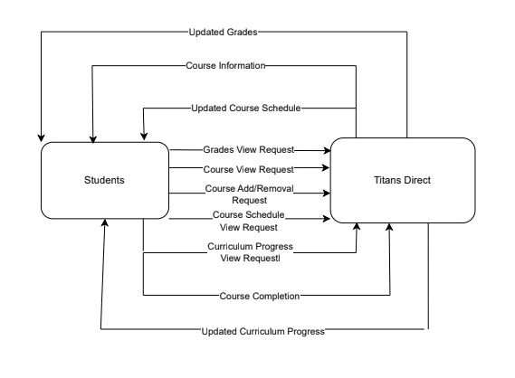

# **Schedule**

*Using MS Project/Project Libre, create a Work Breakdown Structure Chart, identifying all tasks required to complete this team project, dependencies and staff resources for each of the tasks. Include phases to group and organize your tasks and include milestones.*

*Submit the schedule file as a separate file from your plan document.*

# **Staff Organization (MB, VG, CN)**

We have delegated Valarie to be our team leader. We will be delegating certain tasks to the team members as we see fit. We will still be dividing the work equally so that everyone can do their part and the project is completed on time. Valarie will be in charge of making sure that everyone stays on task. Mustafa will be in charge of GitHub, and Valarie will keep Trello updated.

# **Tracking and control mechanisms** (VG)

We plan to monitor the progress of tasks using the Trello board to assign and delegate tasks. We communicate often through the use of a group chat and Slack to ensure everyone is on the same page. We also plan on using platforms that allow for sharing and live changes as often as possible. We use Google Drive to share and collaborate on documents, and GitHub to provide documents and information.